**Test Plan Out Line and Test Scenario Identification for Online Registration Form**

**Introduction**

﻿This test plan outlines the strategy for testing the registration form on our website. This form is crucial as it collects essential user information such as full name, email address, password, date of birth, gender, and newsletter subscription preferences. Our goal is to ensure that the form functions correctly, validates inputs accurately, and uploads the data to the server without any issues.

**Objectives**

1.To verify that the registration form accepts legitimate inputs and presentations appropriate errors messages for invalid inputs.

2.To ensure that the form's validation rules are enforced, together with password requirements and electronic mail format.

3. To verify that statistics is efficaciously submitted to the server upon correct shape finishing touch.

4. To take a look at the usability and person revel in of the shape, making sure it's user -friendly.

**Scope**

The scope of this testing includes:

1. Functional testing of all form fields and validation rules.
2. Usability testing to ensure ease of use and accessibility.
3. Compatibility testing across different browsers and devices.
4. Security testing to protect user data during submission.

**Test Environment**

The test environment will include:

1. Various web browsers (Chrome, Firefox, Edge, Safari) and their latest versions.
2. Different devices (desktop, tablet, mobile).
3. Staging server with the same configuration as the production server.
4. Test tools for automation and manual testing (e.g., Cypress , JIRA, Trello).

**Test Data**

Test data will include:

1. Valid and invalid full names.
2. Valid and invalid email addresses.
3. Passwords of varying lengths and complexities.
4. Matching and non-matching confirm passwords.
5. Various dates of birth, including edge cases.
6. Different gender selections. Male/ Female/ Other
7. Newsletter subscription options. Yes/ NO

**Test Scenarios**

1. **Form Load**

* Verify that the form loads correctly on different browsers and devices.

1. **Full Name Field**

* Validate that the Full Name field accepts alphabetic characters and spaces.
* Check error messages for invalid inputs (e.g., empty field, special characters).

1. **Email Address Field**

* Validate that the Email Address field accepts properly formatted email addresses.
* Check error messages for invalid inputs (e.g., missing "@" symbol).

1. **Password and Confirm Password Fields**

* Validate that the Password field enforces a minimum of 8 characters.
* Check that Confirm Password matches the Password.
* Verify error messages for invalid inputs.

1. **Date of Birth Field**

* Validate that the Date of Birth field accepts valid dates.

1. **Gender Field**

* Verify that the Gender field allows selection from Male, Female, and Other.

1. **Newsletter Subscription**

* Validate that the Newsletter Subscription field correctly records Yes/No selections.

1. **Submit Button**

* Ensure that the form does not submit with invalid inputs.
* Verify successful submission with valid inputs.
* Check server response and data integrity.

**Test Execution Schedule**

* **Week 1:** Prepare test environment and gather test data.
* **Week 2-3:** Execute functional testing and record results.
* **Week 4:** Perform usability and compatibility testing.
* **Week 5:** Conduct security testing and finalize test report.

**Risks and Assumptions**

**Risks:**

* Potential downtime of the staging server.
* Inconsistent behavior across different browsers and devices.

**Assumptions:**

* The development team will fix identified issues promptly.
* The staging environment mirrors the production environment.
* Test data is representative of actual user inputs.

By following this test plan, we aim to ensure that the online registration form functions correctly, provides a positive user experience, and secures user data during submission.

**Test Scenarios**

**Positive Scenarios:**

1. User enters all valid information and submits the form.

2. User opts for the newsletter subscription.

**Negative Scenarios:**

1. User enters an invalid email address.

2. Password and Confirm Password do not match.

**Cypress test Scripts For Registration Form**

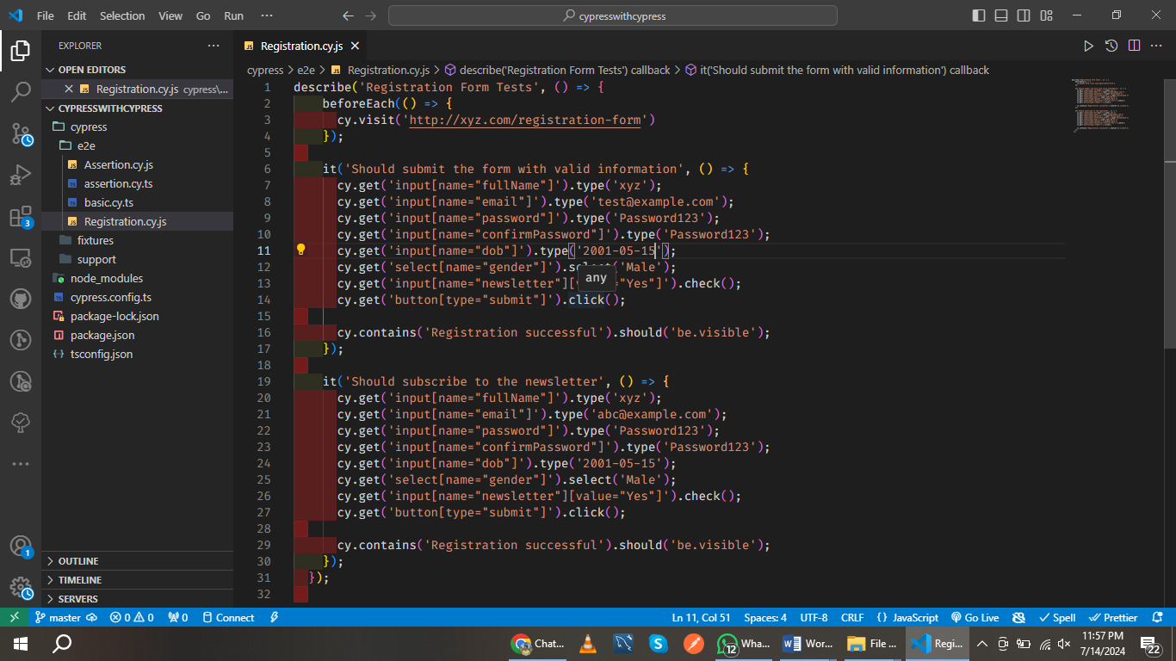

describe('Registration Form Tests', () => {

beforeEach(() => {

cy.visit('http://xyz.com/registration-form')

});

it('Should submit the form with valid information', () => {

cy.get('input[name="fullName"]').type('John Doe');

cy.get('input[name="email"]').type('test@example.com');

cy.get('input[name="password"]').type('Password123');

cy.get('input[name="confirmPassword"]').type('Password123');

cy.get('input[name="dob"]').type('2001-05-15');

cy.get('select[name="gender"]').select('Male');

cy.get('input[name="newsletter"][value="Yes"]').check();

cy.get('button[type="submit"]').click();

cy.contains('Registration successful').should('be.visible');

});

it('Should subscribe to the newsletter', () => {

cy.get('input[name="fullName"]').type('Jane Doe');

cy.get('input[name="email"]').type('abc@example.com');

cy.get('input[name="password"]').type('Password123');

cy.get('input[name="confirmPassword"]').type('Password123');

cy.get('input[name="dob"]').type('2001-05-15');

cy.get('select[name="gender"]').select('Male');

cy.get('input[name="newsletter"][value="Yes"]').check();

cy.get('button[type="submit"]').click();

cy.contains('Registration successful').should('be.visible');

});

});